**Blue Green Deployment**

Blue-Green deployment is DevOps release management technique that reduce downtime and code deployment risk. It use two identical production environment blue and green.it is immutable infrastructure. Where we can’t make change after deployment but we redeploy altogether.

In blue-green there is two separated environment.

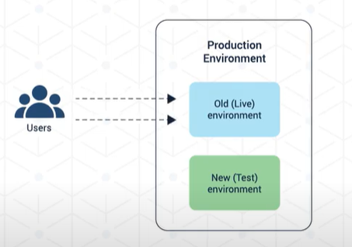

Here Old or live environment is called blue and new and test environment is called green.

Both running on production environment

After test is completed in Test environment all traffic is transferred to green from blue after that blue can stay as standby for rollback or disaster recovery mechanism.

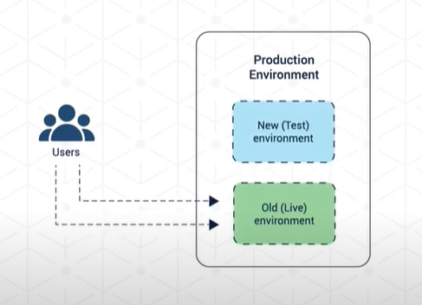

So after that blue become test environment for new code deployment and green become live environment.

**Deploy web app with .net code**

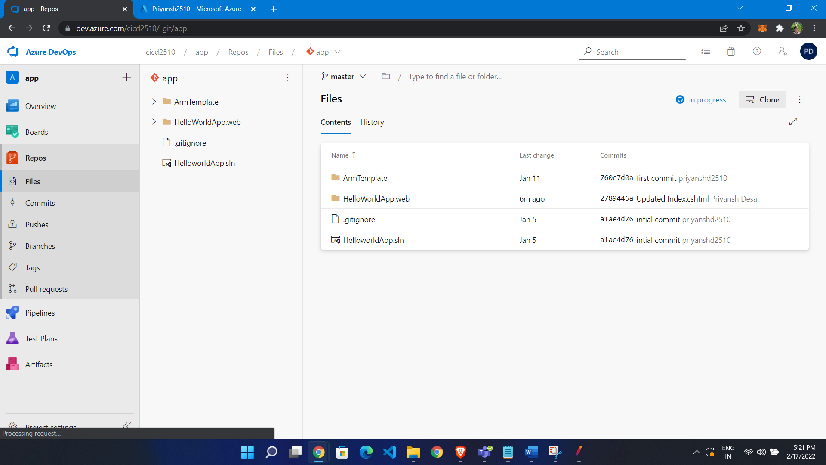

**Build Pipeline:**

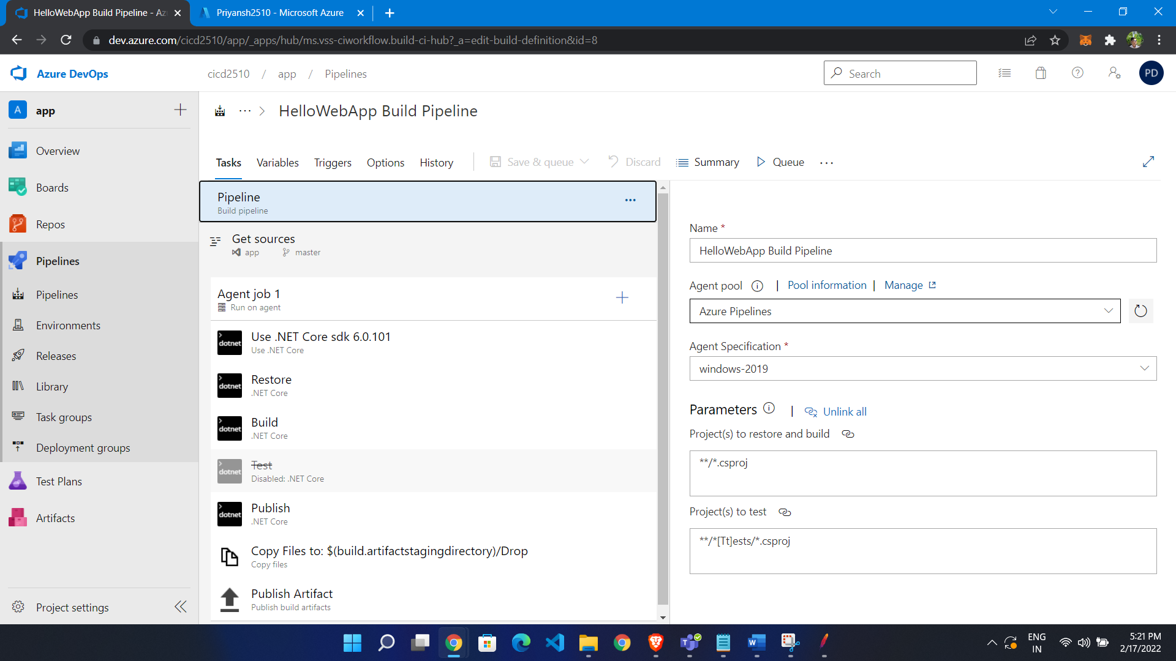

**Release to webapp**

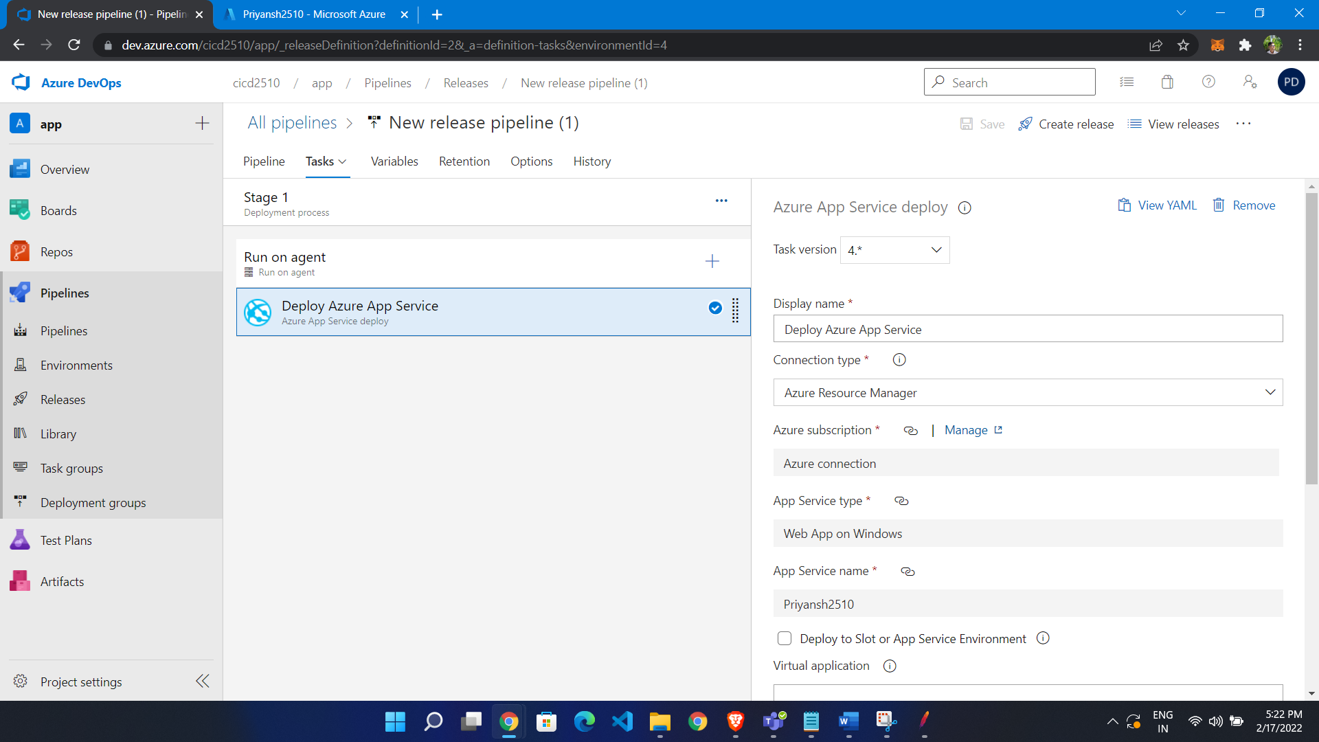

**Make deployment slot in webapp**

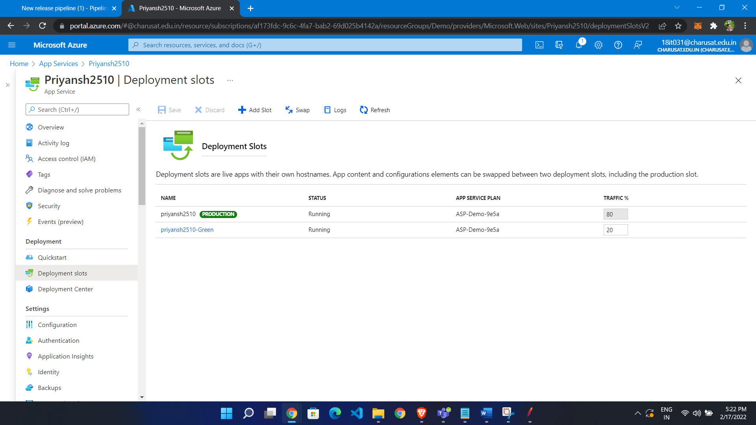

**Deploy code to green deployment slot:**

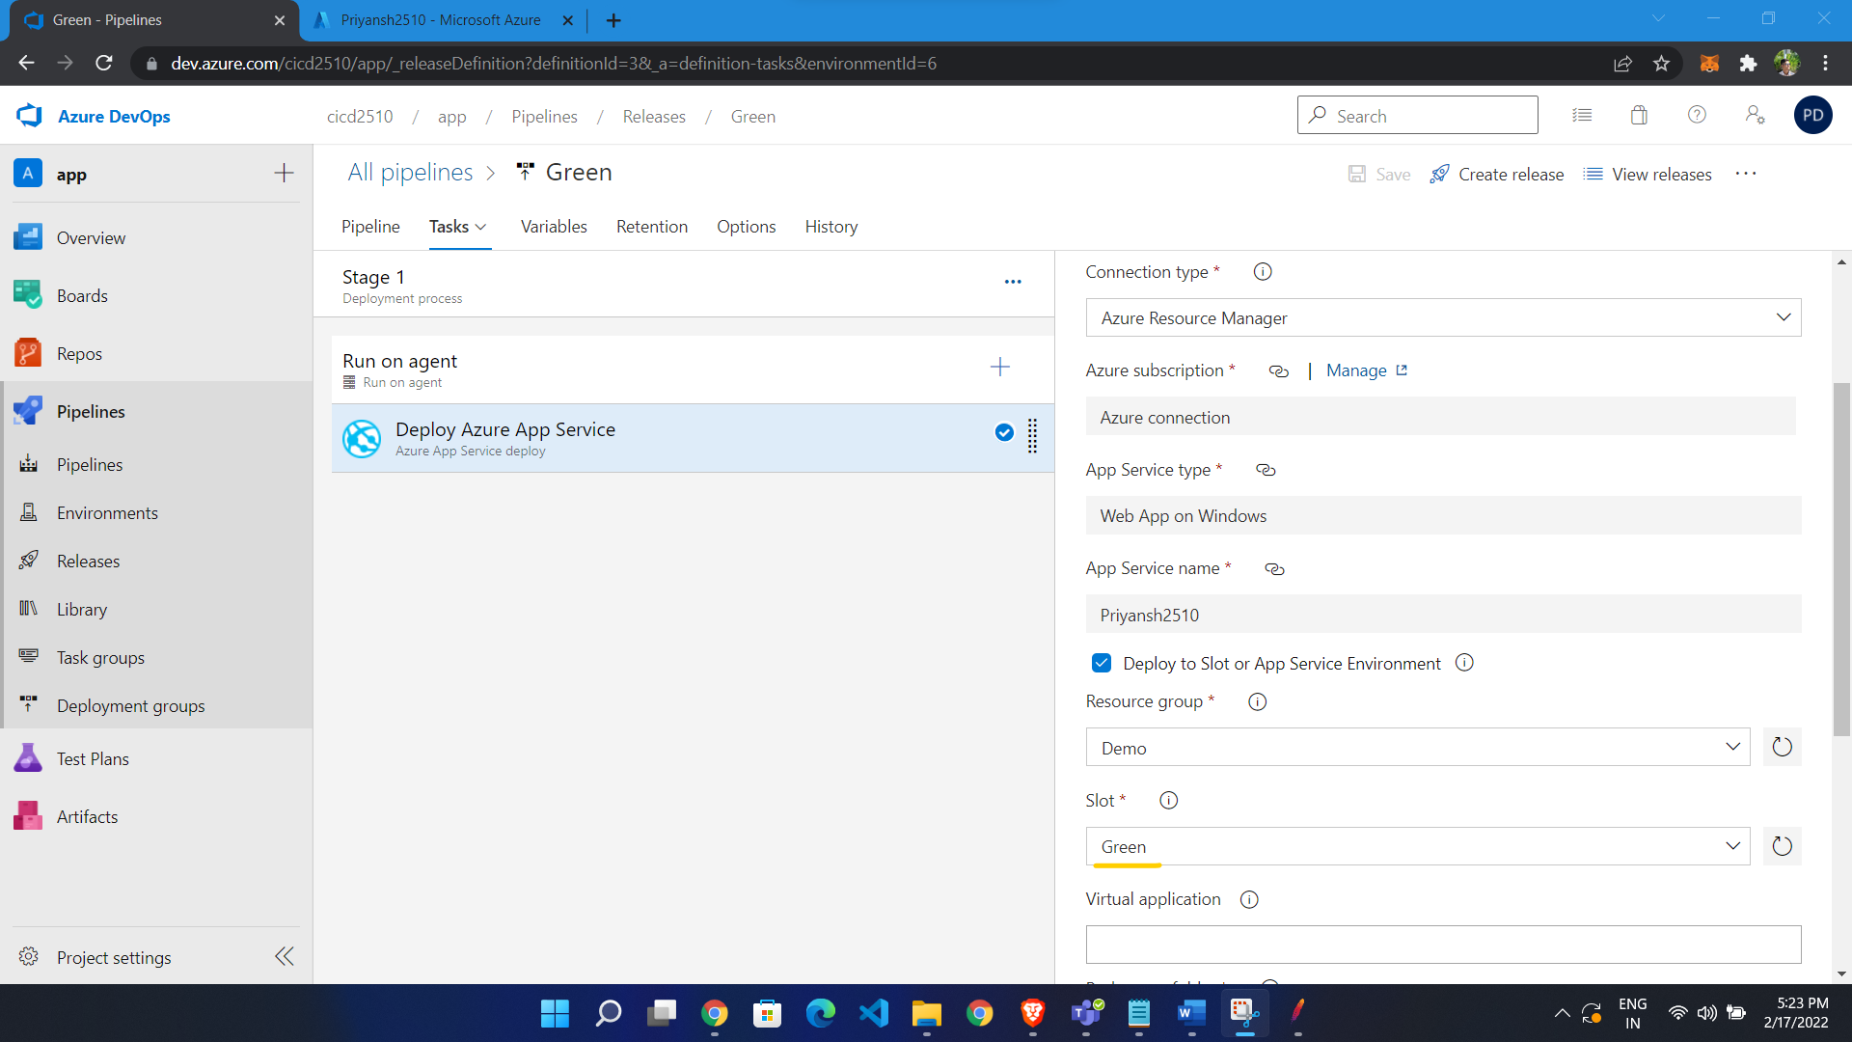

we change slot which we want to move to production

* Go to deployment slot
* Click swap slot

**Now we enable manual autoscaling**

* Click scale out from left side menu
* Click manual scale and add count

**When we swap slot and perform load testing server remains same**

